Junior Kids - EBC

1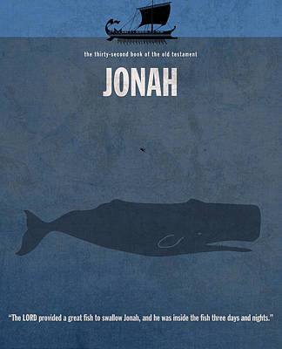

26th April 2020

**Order**

**Song 1 – In The Belly Of A Whale**

**Song 2 – Every Move I Make**

**Bible reading: Jonah 2**

**Song 3 – Strength of My Life**

Song 1 – In The Belly Of A Whale

YouTube link: <https://www.youtube.com/watch?v=BQOoovMOJUM>

Song 2 – Every Move I Make

YouTube link <https://www.youtube.com/watch?v=MPvnZILn6EY>



**JONAH 2**

1From inside the fish, Jonah prayed to the Lord his God:

**2**When I was in trouble, Lord, I prayed to you, and you listened to me.  
From deep in the world of the dead, I begged for your help, and you answered my prayer.

**3**You threw me down to the bottom of the sea. The water was churning all around; I was completely covered by your mighty waves.  
**4**I thought I was swept away from your sight, never again to see your holy temple.

**5**I was almost drowned by the swirling waters that surrounded me.  
Seaweed had wrapped around my head.  
**6**I had sunk down below the underwater mountains; I knew that forever, I would be a prisoner there. But, you, Lord God, rescued me from that pit.  
**7**When my life was slipping away, I remembered you— and in your holy temple you heard my prayer. **8**All who worship worthless idols turn from the God who offers them mercy.  
**9**But with shouts of praise, I will offer a sacrifice to you, my Lord. I will keep my promise, because you are the one with power to save.

**10**The Lord commanded the fish to vomit up Jonah on the shore. And it did.

Did Jonah believed that God would save him? Provide reasons for your answer.

Why did God spare Jonah?

What other event(s) in the bible that is rather similar to Jonah being in the belly of the fish? How are they similar?

Song 3 – Strength of My Life

YouTube link: <https://www.youtube.com/watch?v=6sqy1URx4mg>